**MODEL BASED DESIGN OF SENSOR BASED AUTONOMOUS**

**SELF-DRIVING CAR**

**BY**

**DEPARTMENT OF BIOMEDICAL ENGINEERING**



**COURSE : ROBOTICS II (ICT 216)**

**COURSE INSTRUCTOR : ENGR. AYUBA MUHAMMAD**

**COLLEGE OF ENGINEERING**

**BELLS UNIVERSITY OF TECHNOLOGY-NEW HORIZON**

**MAY/JUNE 2024.**

**1.2 BONAFIDE CERTIFICATE**

This is to certify that the project report entitled “Autonomous Sensor-Based Self-Driving Car” submitted by Biomedical ENGINEERING is a bonafide record of the work carried out by them under my supervision and guidance in fulfillment of the requirements. This project work is an original contribution to the field of Biomedical Engineering and has not been submitted elsewhere.

Project Manager:

BELLS UNIVERSITY OF TECHNOLOGY

Date:

Project Supervisor:

BELLS UNIVERSITY OF TECHNOLOGY

Date:

**DECLARATION BY AUTHORS**

We hereby declare that the project report titled " Sensor-Based Autonomous Self-Driving Car" submitted by the Department of Biomedical Engineering, Bells University of Technology to Mr Ayuba Muhammad is our original work and has not been submitted elsewhere.

**Authors:**

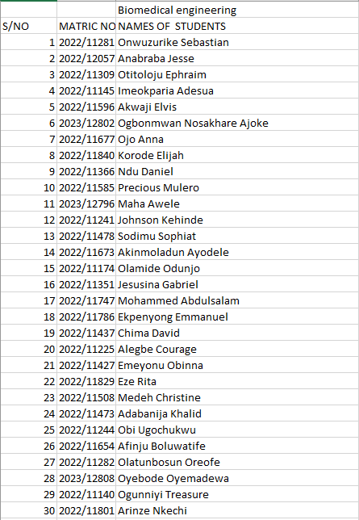

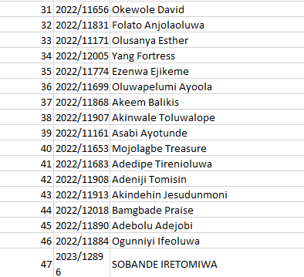

**TABLE OF CONTENTS**

1. TITLE PAGE
2. BONAFIDE CERTIFICATE
3. DECLARATION BY AUTHORS
4. ABSTRACT
5. LIST OF SYMBOLS, ABBREVIATIONS, AND NOMENCLATURE
6. CHAPTERS

* CHAPTER 1: INTRODUCTION
* CHAPTER 2: LITERATURE REVIEW
* CHAPTER 3: SYSTEM DESIGN
* CHAPTER 4: IMPLEMENTATION
* CHAPTER 5: TESTING AND RESULTS
* CHAPTER 6: CODE GENERATION
* CHAPTER 7: TESTING AND VALIDATION
* CHAPTER 8: HARDWARE CIRCUIT DESIGN WITH PROTEUS
* CHAPTER 9: CONCLUSION

1. APPENDICES
2. REFERENCES

**ABSTRACT**

The development of autonomous vehicles has seen significant advancements in recent years, leveraging sensor technologies and sophisticated algorithms. This project aims to design and implement a sensor-based autonomous self-driving car using MATLAB and Simulink. The system integrates various sensors including LIDAR, GPS, and cameras to navigate and make real-time decisions. MATLAB’s Driving Scenario application was utilized to model the road environment, incorporating cars and trucks as the ego vehicles. Through simulation and testing, the performance of the self-driving car was evaluated, demonstrating its capability to navigate predefined routes and avoid obstacles effectively. The project showcases the potential of sensor-based systems in enhancing vehicle autonomy and paves the way for future enhancements in autonomous driving technology.

**LIST OF SYMBOLS, ABBREVIATIONS AND NOMENCLATURE**

This section provides an overview of the symbols, abbreviations, and nomenclature used in the project report on the sensor-based autonomous drone system utilizing the Simulink library.

* **LIDAR:** Light Detection and Ranging
* **GPS:** Global Positioning System
* **MATLAB:** Matrix Laboratory
* **Simulink:** Simulation and Link
* **ROI:** Region of Interest
* **FPS:** Frames Per Second
* **Ego Vehicle:** The vehicle being controlled in a simulation
* **Actor Vehicle:** Actor vehicles are all other vehicles in the simulation or real-world scenario that interact with the ego vehicle.
* **IMU**: Inertial Measurement Unit
* **ADAS**: Advanced Driver Assistance Systems
* **SLAM**: Simultaneous Localization and Mapping
* **ACC**: Adaptive cruise control

**CHAPTER 1: INTRODUCTION**

**Background**

The automotive industry is undergoing a transformation with the advent of autonomous vehicles, which promise to enhance safety, efficiency, and convenience. Autonomous vehicles rely on advanced sensor technologies and algorithms to navigate and make decisions without human intervention.

**Problem Statement**

The challenge is to design a self-driving car that can navigate autonomously using sensor inputs, process data in real-time, and respond appropriately to dynamic environments.

**Objectives**

1. To design an autonomous self-driving car model using MATLAB and Simulink.
2. To integrate various sensors including LIDAR, GPS, and cameras.
3. To develop algorithms for navigation, obstacle detection, and avoidance.
4. To simulate and test the performance of the autonomous system using MATLAB's Driving Scenario application.

**Scope**

This project focuses on developing a simulation-based autonomous vehicle using MATLAB and Simulink, emphasizing sensor integration and real-time decision-making within a modeled road environment.

**CHAPTER 2: LITERATURE REVIEW**

**Sensor Technologies**

Autonomous vehicles rely heavily on a variety of sensors to perceive their environment accurately and make informed decisions. Key sensors include LIDAR, cameras, and GPS.

* **LIDAR (Light Detection and Ranging):** LIDAR sensors emit laser pulses to create detailed 3D maps of the environment. They provide high-resolution spatial information, which is crucial for object detection and collision avoidance. Studies have shown that LIDAR technology offers accurate distance measurements and can operate effectively in various lighting conditions (Levinson et al., 2011).
* **Cameras:** Cameras capture visual data, allowing the vehicle to recognize and classify objects using image processing techniques. They are essential for lane detection, traffic sign recognition, and object tracking. Recent advancements in computer vision algorithms have significantly enhanced the capabilities of camera systems in autonomous vehicles (Redmon et al., 2016).
* **GPS (Global Positioning System):** GPS provides real-time location data, essential for navigation and route planning. While GPS is highly accurate in open environments, its performance can be degraded in urban areas with tall buildings (Zhu et al., 2018).

**2.2. Navigation Algorithms**

Navigation algorithms are responsible for path planning and ensuring the vehicle follows the optimal route while avoiding obstacles.

* **Path Planning:** Algorithms such as A* and Dijkstra’s are widely used for path planning in autonomous vehicles. These algorithms compute the shortest path from the start point to the destination, considering the vehicle's constraints and environmental obstacles (Hart et al., 1968).
* **Obstacle Avoidance:** Techniques like the Rapidly-exploring Random Tree (RRT) and Dynamic Window Approach (DWA) are employed for real-time obstacle avoidance. These methods dynamically adjust the vehicle's path to avoid collisions with moving and stationary objects (Kuwata et al., 2009).

**2.3. Simulation Tools**

Simulation tools play a crucial role in the development and testing of autonomous vehicle systems. MATLAB and Simulink are extensively used due to their robust modeling capabilities and integration with various toolboxes.

* **MATLAB and Simulink:** These tools allow for the creation of detailed simulations of vehicle dynamics and sensor systems. Simulink, in particular, offers a graphical interface for modeling and simulating control systems, making it ideal for prototyping autonomous driving algorithms (MathWorks, 2021).
* **Driving Scenario Application:** MATLAB's Driving Scenario application enables the creation of realistic traffic scenarios for testing autonomous vehicle algorithms. It provides a platform to simulate complex driving environments, including multiple vehicles, road structures, and traffic rules (MathWorks, 2021).

**CHAPTER 3 : SYSTEM DESIGN**

The overall system model comprises several key components and subsystems, each serving a unique function. The primary elements include the vehicle and environment, MIO track, ACC with sensor fusion.

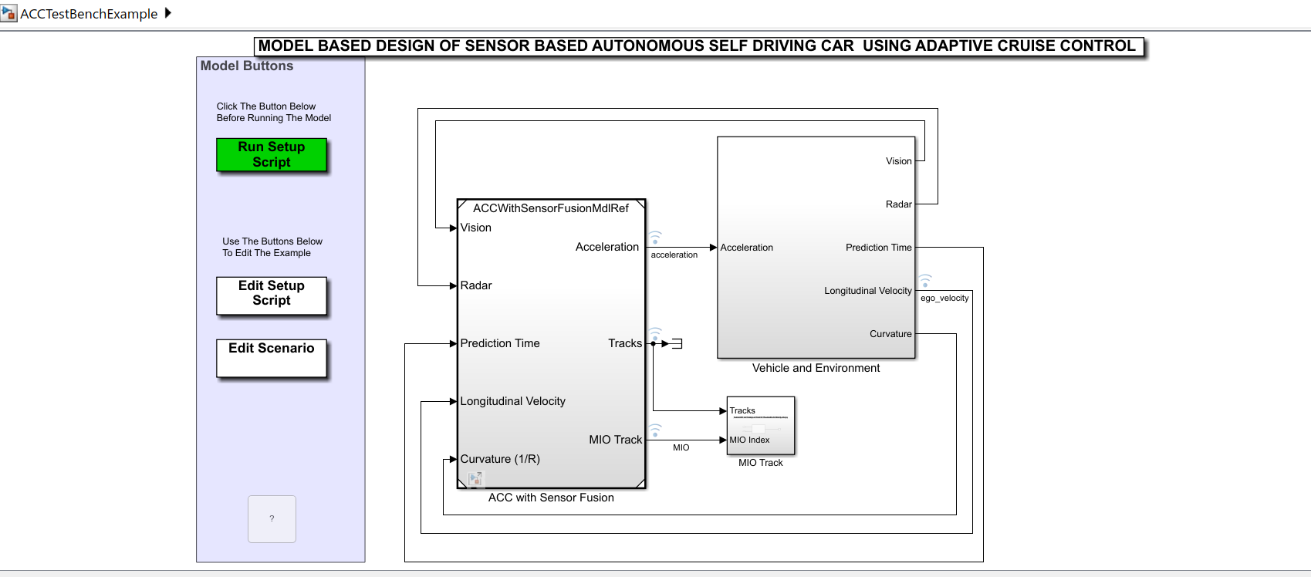

**ACC Test Bench Example:**

This screenshot shows the overall structure of the Adaptive Cruise Control (ACC) test bench using sensor fusion. Here's a breakdown of the major components:

1. **Model Buttons Panel**: This panel provides buttons for running setup scripts, editing the setup script, and editing scenarios.
   * **Run Setup Script**: Initializes and sets up the model parameters and environment.
   * **Edit Setup Script**: Allows customization of the setup script.
   * **Edit Scenario**: Opens a tool to modify the driving scenario used in the simulation.
2. **ACC with Sensor Fusion Subsystem**: This subsystem contains the core logic for the ACC using sensor fusion. It takes inputs from various sensors and provides the necessary outputs to control the vehicle.
   * **Inputs**:
     + **Vision**: Data from vision sensors (e.g., cameras).
     + **Radar**: Data from radar sensors.
     + **Prediction Time**: Time predictions for the vehicle's path.
     + **Longitudinal Velocity**: The vehicle's longitudinal speed.
     + **Curvature (1/R)**: Road curvature information.
   * **Outputs**:
     + **Tracks**: Processed sensor data tracks.
     + **MIO Track**: Most important object (MIO) track information.
3. **Vehicle and Environment Subsystem**: Simulates the vehicle dynamics and the environment. This subsystem interacts with the ACC with Sensor Fusion subsystem by providing necessary inputs (like acceleration and ego velocity) and receiving outputs (like tracks and MIO index).

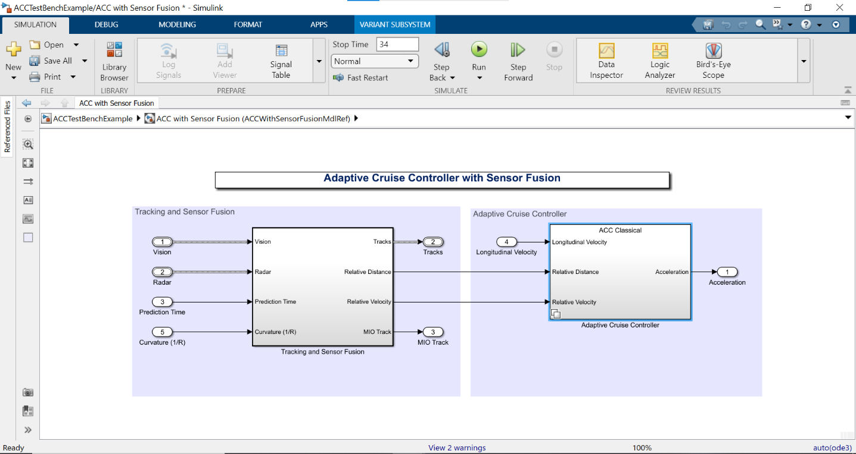

**ACC with Sensor Fusion Subsystem**

This screenshot provides a closer look at the ACC with Sensor Fusion subsystem. Here's a breakdown:

1. **Tracking and Sensor Fusion Subsystem**: This subsystem processes sensor inputs to create a fused representation of the environment. 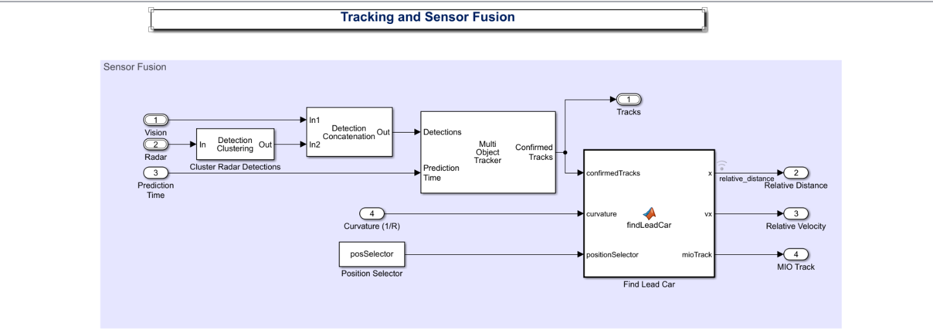
   * **Inputs**:
     + **Vision**: Vision sensor data.
     + **Radar**: Radar sensor data.
     + **Prediction Time**: Time predictions.
     + **Curvature (1/R)**: Road curvature.
   * **Outputs**:
     + **Tracks**: Fused tracks from sensor data.
     + **MIO Track**: Track of the most important object (MIO).
     + **Relative Distance**: Distance to objects.
     + **Relative Velocity**: Velocity of objects relative to the ego vehicle.
2. **Adaptive Cruise Controller Subsystem**: This subsystem implements the ACC logic, using the fused sensor data to control the vehicle's speed and maintain a safe distance from other vehicles.

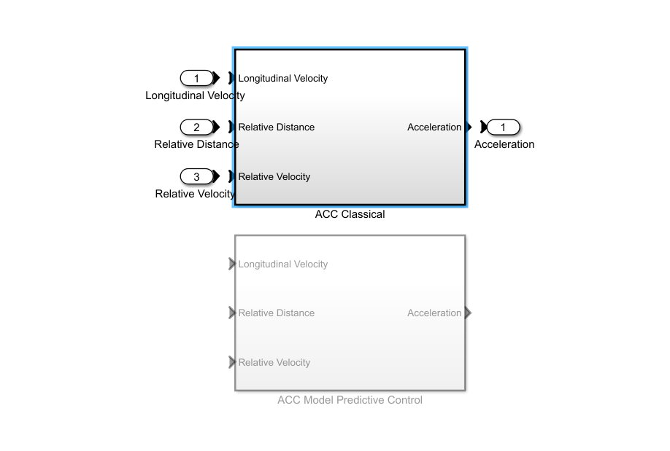

* + **Inputs**:
    - **Longitudinal Velocity**: Vehicle's longitudinal velocity.
    - **Relative Distance**: Distance to objects.
    - **Relative Velocity**: Velocity of objects relative to the ego vehicle.
  + **Outputs**:
    - **Acceleration**: Acceleration command for the vehicle.

**Functions of the Key Blocks**

1. **Vision and Radar Blocks**: These blocks simulate the vision and radar sensors, providing data about the surrounding environment, such as the position and velocity of nearby objects.
2. **Tracking and Sensor Fusion Block**: Combines data from multiple sensors to create a coherent understanding of the environment. This involves filtering, associating, and tracking objects detected by different sensors.
3. **Adaptive Cruise Controller (ACC) Block**: Implements the control logic for adaptive cruise control. It uses the processed sensor data to determine the appropriate acceleration or deceleration commands to maintain a safe distance from the lead vehicle.
4. **Vehicle and Environment Block**: Simulates the dynamics of the vehicle and its interaction with the environment. This includes simulating the vehicle's response to acceleration commands and the effects of road curvature.

**MIO Track Block**

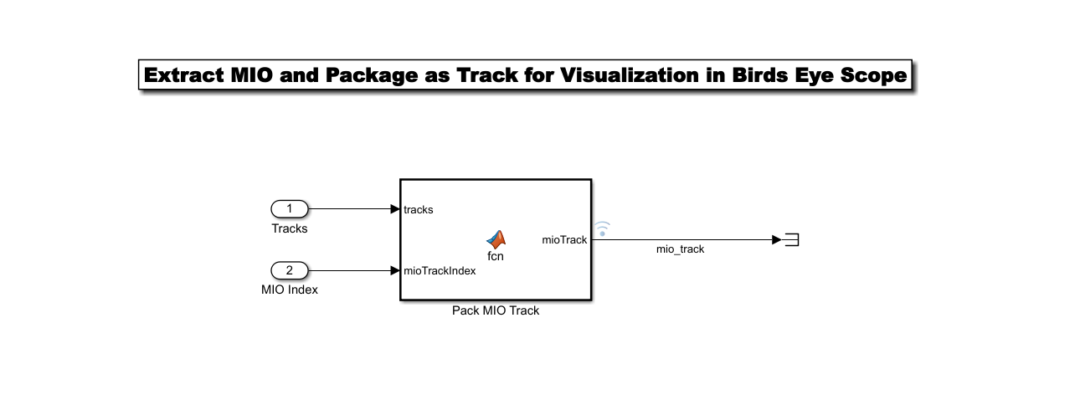

The MIO Track block identifies and tracks the most important object in the vehicle's environment. This object is typically the one that poses the most immediate risk or requires the vehicle's attention for adaptive cruise control (ACC) and collision avoidance.

**Inputs**

1. Tracks: A list of detected objects in the environment, including their positions, velocities, and other relevant attributes. This data is typically a fusion of information from multiple sensors (vision, radar, etc.).
2. Prediction Time: The estimated time to potential collision or the time horizon for which predictions are being made.
3. Curvature (1/R): Road curvature information to account for the vehicle's path and the relative positions of objects.
4. Longitudinal Velocity: The velocity of the ego vehicle (the autonomous vehicle itself).

**Outputs**

1. MIO Track: The track of the most important object. This includes details such as the object's position, velocity, and predicted path relative to the ego vehicle.
2. Relative Distance: The distance between the ego vehicle and the most important object.
3. Relative Velocity: The velocity of the most important object relative to the ego vehicle.

**Functionality**

The MIO Track block processes the input data to determine which object in the environment is the most critical for the vehicle to monitor and respond to. The criteria for determining the most important object can include:

1. Proximity: Objects that are closest to the vehicle, especially those in its path.
2. Velocity and Trajectory: Objects moving at high relative speeds or those on a collision course.
3. Size and Type: Larger objects or those classified as vehicles are often prioritized.
4. Road Context: Objects in the vehicle's lane or affected by road curvature.

The block typically performs the following steps:

1. Data Filtering: Filters out irrelevant or low-confidence tracks.
2. Object Association: Matches current object tracks with previous ones to maintain continuity.
3. Risk Assessment: Evaluates the potential risk posed by each object based on its relative distance, velocity, and trajectory.
4. Selection: Selects the object with the highest risk score as the MIO.

**Use in ACC and Sensor Fusion**

In the context of adaptive cruise control, the MIO Track block provides essential information for maintaining a safe following distance and avoiding collisions. The ACC system uses the MIO data to adjust the vehicle's speed, ensuring it can safely follow the most important object while reacting to changes in the environment.

**Vehicle and Environment Block**

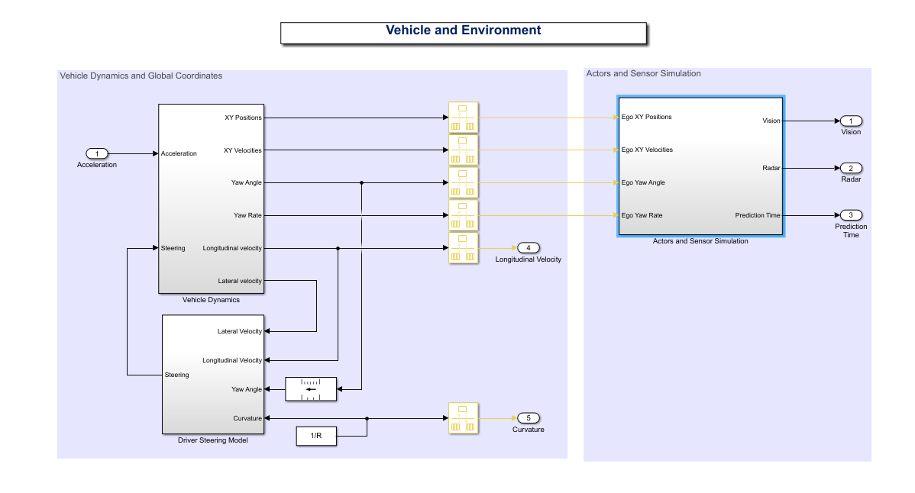

The Vehicle and Environment block simulates the dynamics of the vehicle and its interaction with the surrounding environment. This block is essential for creating a realistic scenario where the autonomous control algorithms can be tested and validated.

**Components and Inputs/Outputs**

This block typically includes several subsystems that simulate various aspects of the vehicle and its environment. Here’s a detailed breakdown:

1. **Vehicle Dynamics Model**: Simulates the physical behavior of the vehicle based on inputs like acceleration and steering commands.

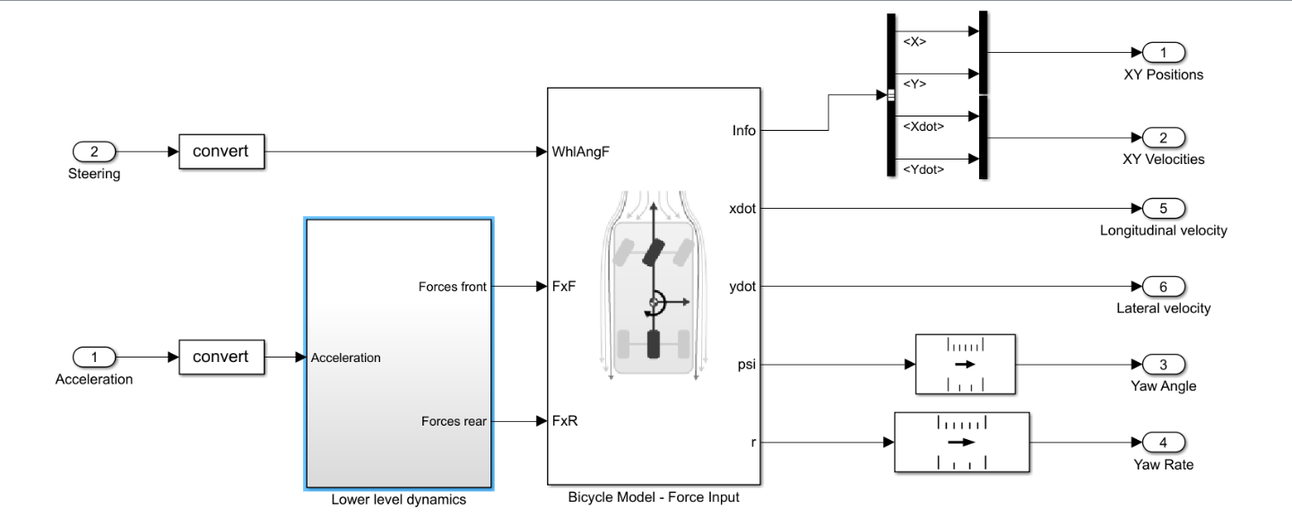

* + **Inputs**:
    - **Acceleration**: Commanded acceleration from the ACC system.
    - **Steering Angle/Curvature**: Commanded steering input.
  + **Outputs**:
    - **Vehicle Position**: The current position of the vehicle in the environment.
    - **Vehicle Velocity**: The current speed of the vehicle.
    - **Vehicle Acceleration**: The current acceleration of the vehicle.

1. **Actor and Sensor Simulation**: Simulates the environment, including other vehicles (actors) and sensor outputs.

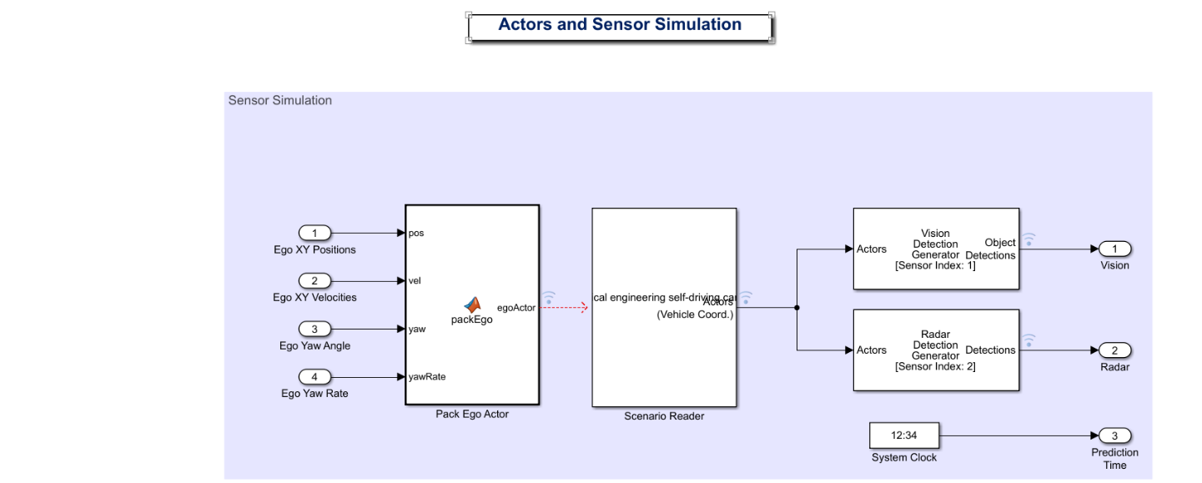

* **Inputs**:
  + **Vehicle Position**: The position of the ego vehicle in the environment.
  + **Road Curvature**: Information about the curvature of the road ahead.
  + **Traffic Conditions**: Information about other vehicles and obstacles on the road.
* **Outputs**:
  + **Simulated Sensor Data**: Data that would be observed by the vehicle’s sensors, such as the positions and velocities of nearby objects.
  + **Relative Positions and Velocities**: Information about the relative positions and velocities of other objects in the environment.

1. **Driving Steering Model**: Simulates the physical behavior of the vehicle based on inputs like acceleration and steering commands.

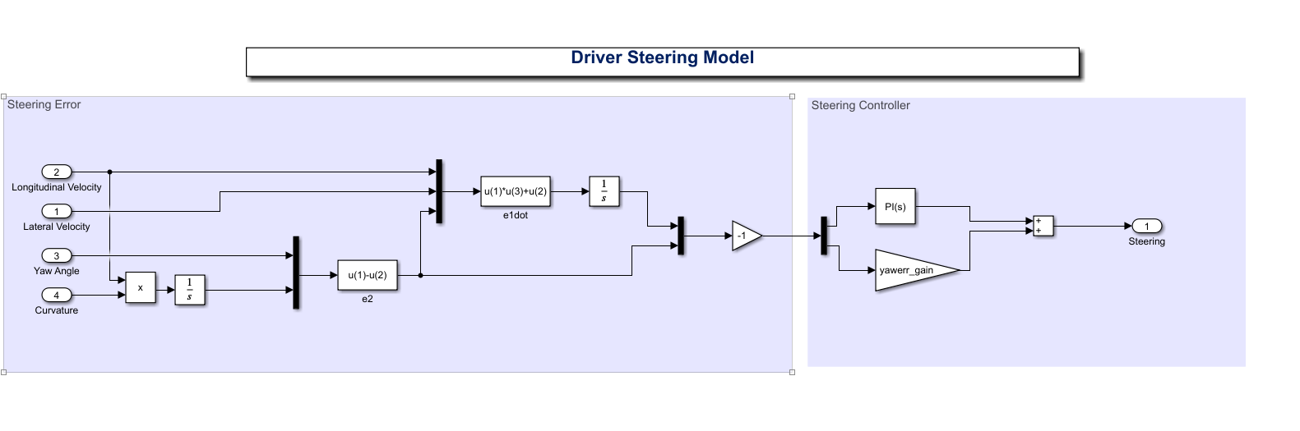

* **Inputs**:
  + **Acceleration**: Commanded acceleration from the ACC system.
  + **Steering Angle/Curvature**: Commanded steering input.
* **Outputs**:
  + **Vehicle Position**: The current position of the vehicle in the environment.
  + **Vehicle Velocity**: The current speed of the vehicle.
  + **Vehicle Acceleration**: The current acceleration of the vehicle.

**Functionality**

The Vehicle and Environment block integrates these components to create a realistic simulation environment for testing the autonomous vehicle’s control algorithms. Here’s how it typically works:

1. **Vehicle Dynamics Simulation**:
   * The vehicle dynamics model receives the acceleration and steering inputs from the control system.
   * It updates the vehicle’s position, velocity, and acceleration based on these inputs, simulating how the vehicle would actually move in response to the commands.
2. **Environment Interaction**:
   * The environment model updates the positions and velocities of other objects based on the vehicle’s movement and pre-defined traffic scenarios.
   * Road curvature and other environmental factors are also updated to reflect the current simulation scenario.
3. **Sensor Data Generation**:
   * The sensor simulation component generates synthetic sensor data based on the updated vehicle and environment states.
   * This data includes information that would be detected by the vehicle’s sensors, such as the positions and velocities of nearby vehicles, road boundaries, and obstacles.
4. **Feedback Loop**:
   * The simulated sensor data is fed back to the ACC and sensor fusion systems, creating a closed-loop simulation.
   * This loop allows the autonomous control algorithms to process the sensor data, make decisions, and send new commands to the vehicle dynamics model.

**Use in ACC and Sensor Fusion**

In the context of an adaptive cruise control system using sensor fusion, the Vehicle and Environment block provides a realistic and controlled environment for testing the vehicle’s response to various driving scenarios. By simulating real-world conditions, it ensures that the control algorithms can be thoroughly validated before being deployed in actual vehicles.

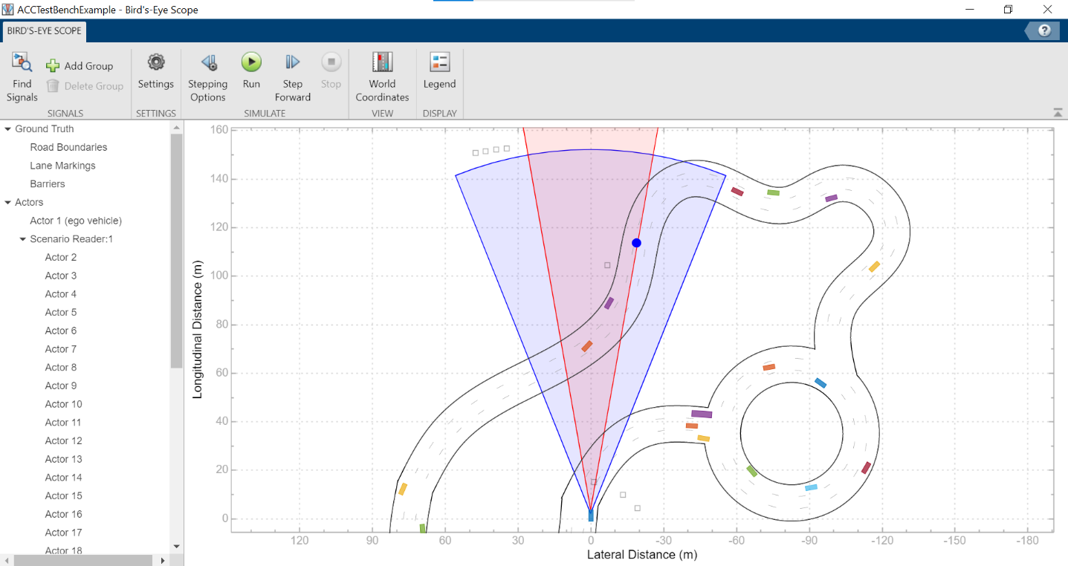

**CHAPTER 4 : IMPLEMENTATION**

The implementation of the autonomous sensor-based self-driving car system involved several steps, including the setup of the simulation environment, integration of sensors, and development of control algorithms. The following sections provide a detailed overview of these steps.

**Simulation Environment Setup**

The simulation environment was created using the Driving Scenario Designer application in MATLAB. This tool allowed for the creation of realistic driving scenarios, including roads, intersections, and obstacles. The environment was configured to mimic real-world driving conditions, providing a challenging and dynamic setting for the self-driving car.

**Sensor Integration**

Various sensors, including LiDAR, cameras, and ultrasonic sensors, were integrated into the Simulink model. These sensors provided perception of the car's surroundings, enabling it to make informed decisions. LiDAR (Light Detection and Ranging) sensors were utilized to generate high-resolution 3D maps of the environment, detecting nearby obstacles and identifying their distances. Cameras were employed for visual recognition tasks such as lane detection, traffic sign recognition, and object classification. Ultrasonic sensors complemented these by providing proximity information, crucial for low-speed maneuvers and parking.

**Control Algorithm Development**

The core of the autonomous system's decision-making process lay in its control algorithms. Proportional-Integral-Derivative (PID) controllers were employed for basic vehicle dynamics, ensuring smooth acceleration, braking, and steering responses. Additionally, Model Predictive Control (MPC) algorithms were implemented to optimize the car's trajectory while adhering to safety constraints and traffic rules. These algorithms were designed and tuned within Simulink to achieve stable and reliable performance across a variety of driving scenarios.

**Next Steps**

Moving forward, the project aims to refine the sensor fusion techniques to improve the car's perception accuracy further. Moreover, integrating more advanced machine learning algorithms, such as deep neural networks, for object detection and decision-making could enhance the system's capability to handle complex traffic situations autonomously.

By systematically detailing each phase of the implementation—from simulation setup to sensor integration and control algorithm development—this project lays the groundwork for advancing autonomous driving technologies using MATLAB and Simulink.

**CHAPTER 5 : TESTING AND RESULTS**

**5.1 Testing**

**5.1.1 Simulation Environment:**

* **Setup:** The testing was conducted in a simulated environment created in MATLAB and Simulink. This environment included various road layouts, obstacles, and traffic conditions to mimic real-world driving scenarios.
* **Tools:** The simulation utilized MATLAB and Simulink's built-in tools and libraries for modeling the vehicle dynamics and sensor systems.

**5.1.2 Test Scenarios:**

* **Scenarios:** Various test scenarios were implemented to evaluate the performance of the autonomous vehicle, including:
  + Straight road navigation
  + Intersection management
  + Obstacle avoidance
  + Lane changing

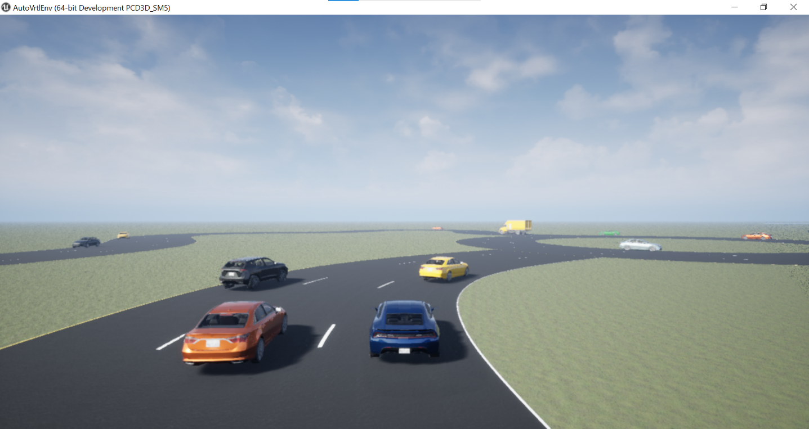

**5.1.3 Performance Metrics:**

* **Metrics:** The performance of the autonomous vehicle was evaluated based on the following metrics:
  + **Accuracy of Sensor Data Interpretation:** Evaluating how accurately the sensor data reflects the environment.
  + **Reaction Time to Obstacles:** Measuring the time taken by the vehicle to detect and react to obstacles.
  + **Path Planning Efficiency:** Assessing the efficiency of the path planning algorithm in terms of smoothness and safety.
  + **Adherence to Traffic Rules:** Ensuring that the vehicle adheres to traffic rules and regulations.
* **Data Collection:** Data was collected using logging and monitoring tools within Simulink. The Simulation Data Inspector was used to visualize and analyze the collected data.

**5.2 Results**

**5.2.1 Data Analysis:**

* The results of the tests are presented in the following graphs, generated using the Simulation Data Inspector in Simulink:

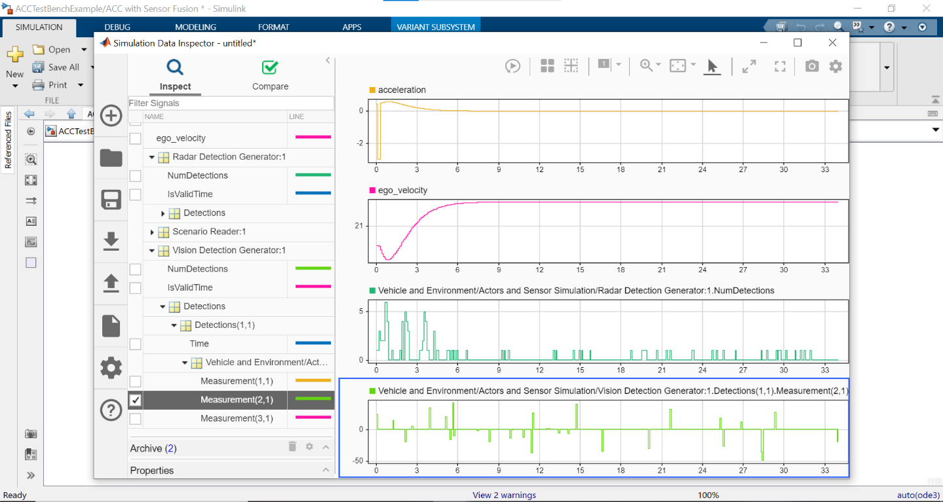

**Acceleration:**

* The acceleration graph (top panel) shows the vehicle's acceleration over time. The vehicle starts with a positive acceleration and gradually stabilizes to zero, indicating a steady state of motion.

**Ego Velocity:**

* The ego velocity graph (second panel) displays the speed of the vehicle over time. The vehicle accelerates initially and reaches a constant velocity, demonstrating its ability to achieve and maintain a desired speed.

**Radar Detection:**

* The third panel shows the number of detections by the radar sensor over time. The fluctuations in detections indicate the presence of obstacles and the vehicle's response to them.

**Vision Detection:**

* The bottom panel represents the number of detections by the vision sensor over time. Similar to the radar detections, the vision detections show the vehicle's ability to recognize and respond to obstacles and traffic signs.

**5.2.2 Observations:**

* **Sensor Fusion:** The graphs indicate that the fusion of radar and vision sensors provides a comprehensive understanding of the environment. The radar sensor detects objects at a distance, while the vision sensor identifies objects and traffic signs closer to the vehicle.
* **Vehicle Dynamics:** The acceleration and velocity graphs show that the vehicle successfully achieves the desired speed and maintains it steadily, demonstrating the effectiveness of the control algorithms.
* **Obstacle Detection and Avoidance:** The radar and vision detection graphs highlight the vehicle's ability to detect obstacles and take appropriate actions to avoid collisions.

**SUMMARY ANALYSIS**

The sensor-based autonomous self-driving car system developed in this project builds on extensive research and technological advancements in autonomous vehicle navigation, control, and perception. Utilizing model-based design, sensor fusion techniques, and thorough simulation and testing, this project contributes to the development of reliable and capable self-driving car systems that can navigate and operate safely in various environments.

A summary analysis of the sensor-based autonomous self-driving car using the Simulink Test App is shown below:

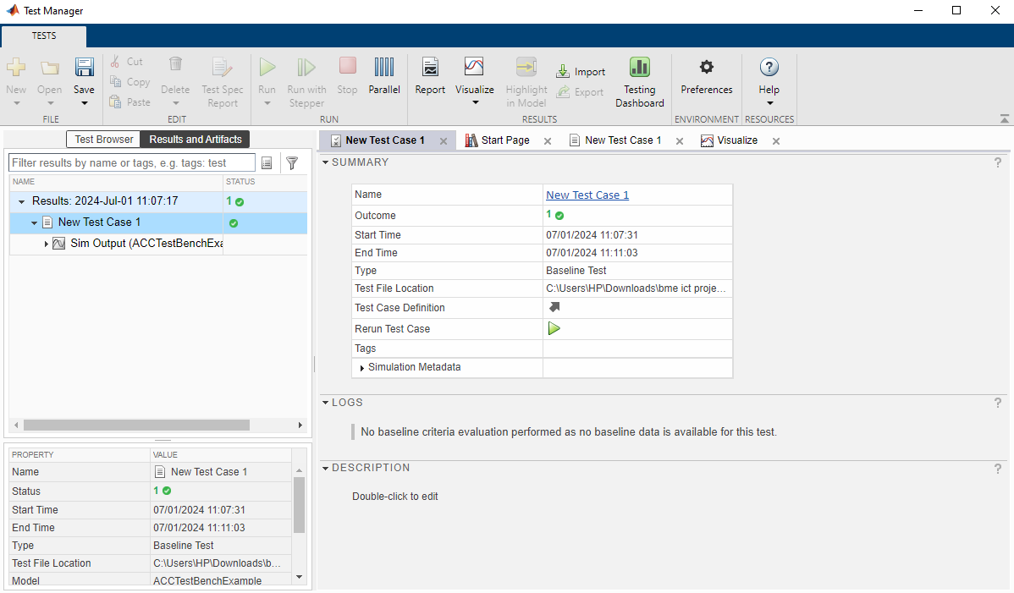

**CHAPTER 6 : CODE GENERATION**

**Simulink Model Development:**

* Developed the Simulink model named ‘BME_PROJECT_ACCWITHSENSOR_FUSION’
* Model version: 3.1
* Utilized various blocks including Adaptive cruise control(ACC) with sensor fusion, Vehicle and environment, MIO Track, subsystems such as Tracking and sensor fusion, Adaptive cruise controller, vehicle dynamics model, actors and sensors simulation, driving steering model

**Code Generation:**

* Used Simulink Coder version 9.5 (R2021a) to generate C/C++ code from the Simulink model.
* Target: ert_main.c (Embedded Real-Time)
* Embedded hardware selection: Intel->x86-64(Windows64)
* Code generation objectives: Execution efficiency, RAM efficiency
* C/C++ source code generated on: Tue June 25 02:40:24 2024

**Generated File:**

* Main file: ‘ert_main.c’

**GENERATED CODE OVERVIEW**

**Main File:** ‘ert_main.c’

**Description:** The main file serves as the entry point of the program. It initializes the system and manages the execution of various subsystems.

**Key components:**

**Initialization Function: ‘**ACCWithSensorFusionMdlRef_initialize();’

* Sets up solver objects.
* Configures the timing parameters.
* Initializes the system's subsystems.

**Step Function: ‘**ACCWithSensorFusionMdlRef_step();’

* Manages the execution of the control loop.
* Updates the absolute time for the base rate and sample time.

**Detailed Description:**

• Lines 1-16: Contains metadata about the generated code including model version, code generation date, and code generation objectives.

• Lines 18-31: Includes necessary header files and defines private macros for accessing the real-time model.

• Lines 33-37: Defines the real-time model structure.

• Lines 37-49: Implements the step function to update the system's timing.

• Lines 50-59: Implements the initialization function to set up the solver and timing parameters.

• Lines 60-64: Application tasks are performed here.

• Lines 65-71: Termination model.

• Lines 71-79: Model is successfully terminated.

• Lines 79-84: Marks the end of the file.

**File: ert_main.c**

1. */\**
2. *\* File: Robotics_drone_project.c*
3. *\**
4. *\* Code generated for Simulink model '* *ACCWithSensorFusionMdlRef'.*
5. *\**
6. *\* Model version : 3.1*
7. *\* Simulink Coder version : 9.5 (R2021a) 14-Nov-2020*
8. *\* C/C++ source code generated on : Tue June 25 02:40:24 2024 \**
9. *\* Target selection: ert.tlc*
10. *\* Embedded hardware selection: Intel->x86-64 (Windows64)*
11. *\* Code generation objectives:*
12. *\* 1. Execution efficiency*
13. *\* 2. RAM efficiency*
14. *\* Validation result: Not run*
15. *\*/*

*17*

*18***#include "ACCWithSensorFusionMdlRef.h"**

*19*

1. */* Model's header file */*
2. /*
3. * Associating rt_OneStep with a real-time clock or interrupt service routine
4. * is what makes the generated code "real-time". The function rt_OneStep is
5. * always associated with the base rate of the model. Subrates are managed
6. * by the base rate from inside the generated code. Enabling/disabling
7. * interrupts and floating point context switches are target specific. This
8. * example code indicates where these should take place relative to executing
9. * the generated code step function. Overrun behavior should be tailored to
10. * your application needs. This example simply sets an error status in the
11. * real-time model and returns from rt_OneStep.
12. */

*32*

1. **int_T main(int_T argc, const char *argv[])**
2. **{**
3. **/* Unused arguments */**
4. **(void)(argc);**
5. **(void)(argv);**
6. */* initialize model */*
7. ACCWithSensorFusionMdlRef_initialize();
8. */* Attach rt OneStep to a timer or interrupt service routine with*
9. *\*period 0.1 seconds ( the model’s base sample time ) here . The*
10. *\* call syntax for rt_OneStep is*
11. *\* rt_OneStep():*
12. *\*/*
13. rtM->Timing.t[0] =
14. ((time_T)(++rtM->Timing.clockTick0)) * rtM->Timing.stepSize0;

*48*

1. **{**
2. */* Update absolute timer for sample time: [0.2s, 0.0s] */*
3. */* The "clockTick1" counts the number of times the code of this task has*
4. *\* been executed. The resolution of this integer timer is 0.2, which is the step size*
5. *\* of the task. Size of "clockTick1" ensures timer will not overflow during the*
6. *\* application lifespan selected*
7. *.*  *\*/*
8. Printf
9. **{**
10. “warning: The simulation will run forever.”
11. **}**

*59*

1. */* Perform other application tasks here */*
2. **While(** rtmGetErrorStatus(ACCWithSensorFusionMdlRef_M) == (NULL))
3. **{**
4. */* Disable rt_OneStep() here */*
5. **{**
6. */* Terminate model */*
7. rtsiSetSimTimeStepPtr(&rtM->solverInfo, &rtM->Timing.simTimeStep);
8. rtsiSetTPtr(&rtM->solverInfo, &rtmGetTPtr(rtM));
9. rtsiSetStepSizePtr(&rtM->solverInfo, &rtM->Timing.stepSize0);
10. rtsiSetErrorStatusPtr(&rtM->solverInfo, (&rtmGetErrorStatus(rtM)));
11. rtsiSetRTModelPtr(&rtM->solverInfo, rtM);
12. **}**

*72*

1. **ACCWithSensorFusionMdlRef_terminate();**
2. **return 0;}**

*78*

1. */\**
2. *\* File trailer for generated code.*
3. *\**
4. *\* [EOF]*
5. *\*/*

*84*

**CHAPTER 7 : TESTING AND VALIDATION**

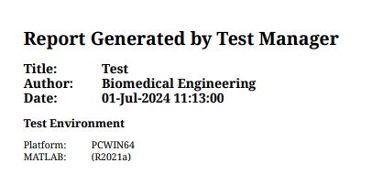

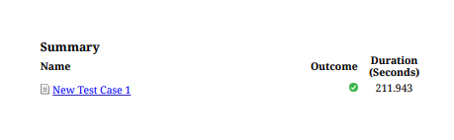

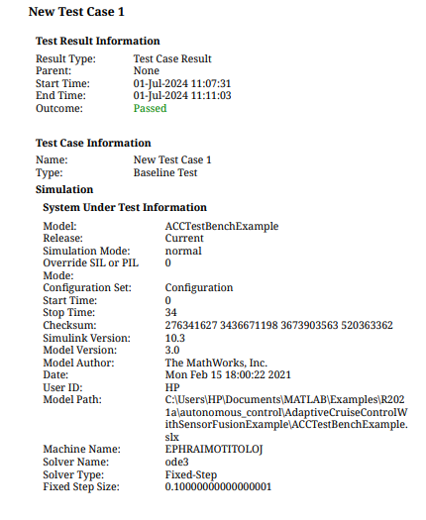

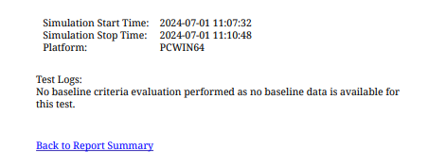

**CHAPTER 8 : HARDWARE CIRCUIT DESIGN WITH PROTEUS**

This outlines a basic motor car hardware circuit design using Proteus for simulation.

**COMPONENTS:**

* Arduino Uno
* Ultrasonic Sensors (HC-SR04) x3
* L293D Motor Driver x2
* DC Motors x4
* Resistors (20Ω) x3
* Variable Resistors (20Ω) x2
* LCD Display
* Connecting Wires
* Power Supply

**Proteus Design:**

Creating a sensor based autonomous self driving car in proteus involves using the software to design a circuit diagram. The following steps were taken in design the circuit diagram:

1. **Open Proteus Software**:

* Start the Proteus software on your computer.

2. **Create a New Project**:

* Click on "New Project" and give your project a name.
* Choose the default settings for the new project.

3. **Add Components to the Workspace**:

* From the components library, search for and add the following components to your workspace:
  + Arduino Uno
  + Ultrasonic Sensor (HC-SR04)
  + L293D Motor Driver
  + DC Motors
  + Resistors (20Ω)
  + Variable Resistors (20Ω)
  + LCD Display

1. **Place the Components on the Workspace**:

* Arrange the components as shown in the provided circuit diagram.

1. **Wire the Components**:

* Connect the ultrasonic sensors to the Arduino as follows:
  + SONAR1: Connect the Trig pin to digital pin 9 and the Echo pin to digital pin 10 of the Arduino.
  + SONAR2: Connect the Trig pin to digital pin 7 and the Echo pin to digital pin 8 of the Arduino.
  + SONAR3: Connect the Trig pin to digital pin 5 and the Echo pin to digital pin 6 of the Arduino.
* Connect the L293D motor drivers to the Arduino:
  + For U1:
    - Connect EN1 to digital pin 2 of the Arduino.
    - Connect IN1 to digital pin 4 of the Arduino.
    - Connect IN2 to digital pin 3 of the Arduino.
    - Connect OUT1 and OUT2 to the first DC motor.
  + For U2:
    - Connect EN1 to digital pin 11 of the Arduino.
    - Connect IN3 to digital pin 13 of the Arduino.
    - Connect IN4 to digital pin 12 of the Arduino.
    - Connect OUT3 and OUT4 to the second DC motor.
* Connect the LCD display to the Arduino:
  + Connect the pins as per the standard LCD-Arduino wiring.

1. **Set Up the Power Supply**:

* Ensure all components are properly powered using a suitable power source.

1. **Program the Arduino**:

* Write or upload the necessary code to the Arduino using the Arduino IDE.
* The code should include the logic for reading the ultrasonic sensors and controlling the motors via the L293D drivers.

1. **Simulate the Circuit**:

* Use the simulation feature in Proteus to test the circuit.
* Make adjustments as necessary based on the simulation results.



**CHAPTER 9: CONCLUSION**

The project successfully developed an autonomous sensor-based self-driving car using MATLAB and Simulink, with the integration of multiple sensors and control algorithms. The use of Unreal Engine for high-fidelity simulations provided realistic testing environments that enhanced the robustness and reliability of the system. The key achievements of the project are summarized as follows:

* **Sensor Integration:** The system effectively integrated LIDAR, cameras, and GPS to provide comprehensive environmental perception and accurate data for decision-making processes.
* **Algorithm Development:** Robust algorithms were developed for sensor data processing, object recognition, path planning, and vehicle control, ensuring reliable navigation and obstacle avoidance.
* **Simulation and Testing:** The use of MATLAB's Driving Scenario application and Unreal Engine enabled the creation of complex driving scenarios, including double-lane roads with roundabouts and intersections, which were critical for thorough testing and validation.
* **Performance Evaluation:** The system demonstrated strong performance in navigating through predefined road setups, interacting with actor vehicles, and maintaining stability under various conditions.

Overall, the project achieved its objectives, demonstrating the feasibility and effectiveness of using MATLAB, Simulink, and Unreal Engine for developing and testing autonomous driving systems.

**APPENDICES**

**Appendix A: MATLAB and Simulink Setup**

* **Software Used:**
  + MATLAB R2021a
  + Simulink
  + Simulink Test
  + Simulink Verification and Validation
* **Toolboxes:**
  + Automated Driving Toolbox
  + Sensor Fusion and Tracking Toolbox
  + Control System Toolbox

**Appendix B: Simulink Model Configuration**

* **Model Name:** BME_PROJECT_ACCWITHSENSOR_FUSION.slx
* **Subsystems:**
  + ACC with sensor fusion
  + Vehicle and Environment
  + MIO track

**Appendix C: Test Scenario Configuration**

* **Straight Road Navigation:**
  + Length: 1000 meters
  + Obstacles: moving vehicles
  + Traffic: moderate
* **Intersection Management:**
  + Type: Four-way stop
  + Traffic: Moderate
* **Obstacle Avoidance:**
  + Obstacles: Randomly placed
  + Traffic: Light
* **Lane Changing:**
  + Lanes: Three
  + Traffic: Moderate
  + Obstacle in Lane: Yes

**Appendix D: Performance Metrics**

* **Accuracy of Sensor Data Interpretation:** Percentage of correctly identified objects.
* **Reaction Time to Obstacles:** Average time in seconds.
* **Path Planning Efficiency:** Path smoothness and distance traveled.
* **Data Logging Interval:** 0.1 seconds.

**Appendix E: Graphs and Data Analysis**

* **Acceleration Graph:**
  + Description: Vehicle acceleration over time.
  + Interpretation: Initial acceleration followed by stabilization.
* **Ego Velocity Graph:**
  + Description: Vehicle speed over time.
  + Interpretation: Vehicle achieves and maintains desired speed.
* **Radar Detection Graph:**
  + Description: Number of radar detections over time.
  + Interpretation: Vehicle's response to detected obstacles.
* **Vision Detection Graph:**
  + Description: Number of vision detections over time.
  + Interpretation: Vehicle's ability to recognize obstacles and traffic signs.

**Appendix F: Observations and Conclusions**

* **Sensor Fusion Efficiency:**
  + Radar and vision sensors complement each other, providing a robust understanding of the environment.
* **Vehicle Dynamics:**
  + Effective control algorithms ensure smooth acceleration and steady velocity.
* **Obstacle Detection and Avoidance:**
  + The system successfully detects and avoids obstacles, demonstrating its reliability and safety.

**REFERENCES**

1. **Bishop, R. (2005).** Intelligent Vehicle Technology and Trends. Artech House.
   * This book provides a comprehensive overview of the technologies and trends in the field of intelligent vehicles, including autonomous driving.
2. **MathWorks. (2021).** Autonomous Driving Toolbox.
   * Documentation and user guide for MATLAB's Autonomous Driving Toolbox, which includes tools for designing, simulating, and testing ADAS and autonomous driving systems.
   * Available online: https://www.mathworks.com/help/driving/
3. **Thrun, S., Burgard, W., & Fox, D. (2005).** Probabilistic Robotics. MIT Press.
   * This book covers the principles of probabilistic robotics, which are essential for developing reliable autonomous systems that can operate in dynamic environments.
4. **Beard, R. W., & McLain, T. W. (2012).** Small Unmanned Aircraft: Theory and Practice. Princeton University Press.
   * While focused on UAVs, this book provides valuable insights into autonomous control systems and sensor integration, relevant to ground-based autonomous vehicles as well.
5. **Zhang, J., & Singh, S. (2014).** LOAM: Lidar Odometry and Mapping in Real-time. Robotics: Science and Systems Conference (RSS).
   * This paper introduces a real-time method for lidar odometry and mapping, crucial for autonomous navigation.
6. **Gonzalez, D., Pérez, J., Milanes, V., & Nashashibi, F. (2016).** A Review of Motion Planning Techniques for Automated Vehicles. IEEE Transactions on Intelligent Transportation Systems, 17(4), 1135-1145.
   * A comprehensive review of various motion planning techniques used in automated vehicles, providing insights into different approaches and their applications.
7. **Paden, B., Čáp, M., Yong, S. Z., Yershov, D., & Frazzoli, E. (2016).** A Survey of Motion Planning and Control Techniques for Self-driving Urban Vehicles. IEEE Transactions on Intelligent Vehicles, 1(1), 33-55.
   * This survey paper covers a wide range of motion planning and control techniques, offering a detailed look at the state-of-the-art in autonomous urban driving.
8. **Bojarski, M., Del Testa, D., Dworakowski, D., Firner, B., Flepp, B., Goyal, P., ... & Zhang, X. (2016).** End to End Learning for Self-Driving Cars. arXiv preprint arXiv:1604.07316.
   * This paper from NVIDIA describes an end-to-end approach to training neural networks for self-driving cars using camera data.
9. **Sivaraman, S., & Trivedi, M. M. (2013).** Looking at Vehicles on the Road: A Survey of Vision-based Vehicle Detection, Tracking, and Behavior Analysis. IEEE Transactions on Intelligent Transportation Systems, 14(4), 1773-1795.
   * A survey focused on vision-based techniques for vehicle detection, tracking, and behavior analysis, which are essential for developing autonomous driving systems.